**Lab Sheet 5**

1. WAP using JavaFX to implement JavaFX Layouts: FlowPane, BorderPane, Hbox, VBox, GridPane.

**Source code:**

**package** com.JAVAFX.javafx_demo;

**import** javafx.application.Application;

**import** javafx.geometry.Insets;

**import** javafx.scene.Scene;

**import** javafx.scene.control.Button;

**import** javafx.scene.layout.BorderPane;

**import** javafx.scene.layout.FlowPane;

**import** javafx.scene.layout.GridPane;

**import** javafx.scene.layout.HBox;

**import** javafx.scene.layout.VBox;

**import** javafx.stage.Stage;

**public** **class** App **extends** Application {

@Override

**public** **void** start(Stage primaryStage) {

primaryStage.setTitle("JavaFX Layout Example");

// FlowPane

FlowPane flowPane = **new** FlowPane();

flowPane.setHgap(10);

flowPane.setVgap(10);

flowPane.getChildren().addAll(**new** Button("Button 1"), **new** Button("Button 2"), **new** Button("Button 3"));

// BorderPane

BorderPane borderPane = **new** BorderPane();

borderPane.setTop(**new** Button("Top"));

borderPane.setLeft(**new** Button("Left"));

borderPane.setCenter(**new** Button("Center"));

borderPane.setRight(**new** Button("Right"));

borderPane.setBottom(**new** Button("Bottom"));

// HBox

HBox hBox = **new** HBox(10);

hBox.getChildren().addAll(**new** Button("Button A"), **new** Button("Button B"), **new** Button("Button C"));

// VBox

VBox vBox = **new** VBox(10);

vBox.getChildren().addAll(**new** Button("Button X"), **new** Button("Button Y"), **new** Button("Button Z"));

// GridPane

GridPane gridPane = **new** GridPane();

gridPane.setHgap(10);

gridPane.setVgap(10);

gridPane.setPadding(**new** Insets(10));

gridPane.add(**new** Button("1,1"), 0, 0);

gridPane.add(**new** Button("2,1"), 1, 0);

gridPane.add(**new** Button("1,2"), 0, 1);

gridPane.add(**new** Button("2,2"), 1, 1);

// Set up the scene

Scene scene = **new** Scene(**new** VBox(flowPane, borderPane, hBox, vBox, gridPane), 400, 400);

primaryStage.setScene(scene);

// Show the stage

primaryStage.show();

}

**public** **static** **void** main(String[] args) {

*launch*(args);

}

}

**Output:**

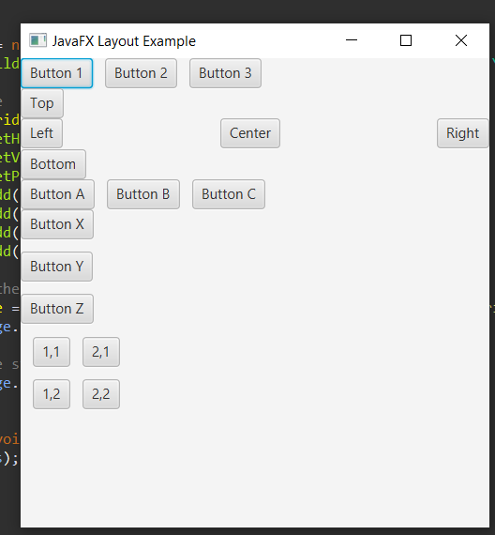

1. WAP using JavaFX to implement JavaFX UI Controls: Label, TextField, Button, RadioButton, CheckBox, Hyperlink, Menu, Tooltip, FileChooser.

**Source code:**

**package** com.JAVAFX2.javafx_demo2;

**import** javafx.application.Application;

**import** javafx.scene.Scene;

**import** javafx.scene.control.*;

**import** javafx.scene.layout.VBox;

**import** javafx.stage.FileChooser;

**import** javafx.stage.Stage;

**import** java.io.File;

**public** **class** MainApp **extends** Application {

@Override

**public** **void** start(Stage primaryStage) {

primaryStage.setTitle("JavaFX UI Controls Example");

// Label

Label label = **new** Label("Enter your name:");

// TextField

TextField textField = **new** TextField();

// Button

Button button = **new** Button("Say Hello");

button.setOnAction(event -> {

String name = textField.getText();

**if** (!name.isEmpty()) {

Alert alert = **new** Alert(Alert.AlertType.***INFORMATION***);

alert.setTitle("Greeting");

alert.setHeaderText(**null**);

alert.setContentText("Hello, " + name + "!");

alert.showAndWait();

}

});

// RadioButton

ToggleGroup radioGroup = **new** ToggleGroup();

RadioButton radioButton1 = **new** RadioButton("Option 1");

RadioButton radioButton2 = **new** RadioButton("Option 2");

radioButton1.setToggleGroup(radioGroup);

radioButton2.setToggleGroup(radioGroup);

// CheckBox

CheckBox checkBox = **new** CheckBox("Check me");

// Hyperlink

Hyperlink hyperlink = **new** Hyperlink("Open Google");

hyperlink.setOnAction(event -> getHostServices().showDocument("https://www.google.com"));

// Menu

MenuBar menuBar = **new** MenuBar();

Menu fileMenu = **new** Menu("File");

MenuItem openMenuItem = **new** MenuItem("Open");

openMenuItem.setOnAction(event -> openFile());

fileMenu.getItems().add(openMenuItem);

menuBar.getMenus().add(fileMenu);

// Tooltip

Tooltip tooltip = **new** Tooltip("Click me!");

button.setTooltip(tooltip);

// VBox to hold all controls

VBox vbox = **new** VBox(10);

vbox.getChildren().addAll(label, textField, button, radioButton1, radioButton2, checkBox, hyperlink, menuBar);

// Set up the scene

Scene scene = **new** Scene(vbox, 400, 300);

primaryStage.setScene(scene);

// Show the stage

primaryStage.show();

}

**private** **void** openFile() {

FileChooser fileChooser = **new** FileChooser();

fileChooser.setTitle("Open File");

File selectedFile = fileChooser.showOpenDialog(**null**);

**if** (selectedFile != **null**) {

Alert alert = **new** Alert(Alert.AlertType.***INFORMATION***);

alert.setTitle("File Opened");

alert.setHeaderText(**null**);

alert.setContentText("Selected file: " + selectedFile.getAbsolutePath());

alert.showAndWait();

}

}

**public** **static** **void** main(String[] args) {

*launch*(args);

}

}

**Output:**

